**ARCHITECTURE DIAGRAM**

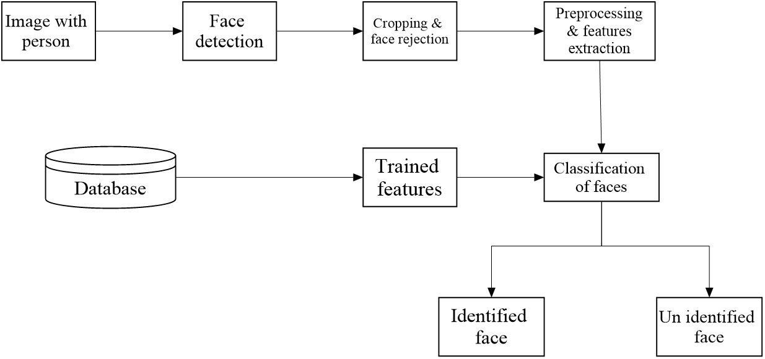

**DATA FLOW DIAGRAM**

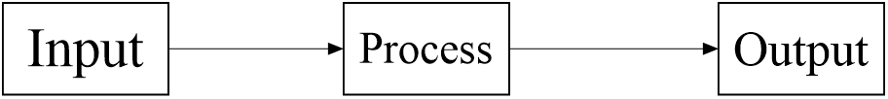



**USE CASE DIAGRAM**

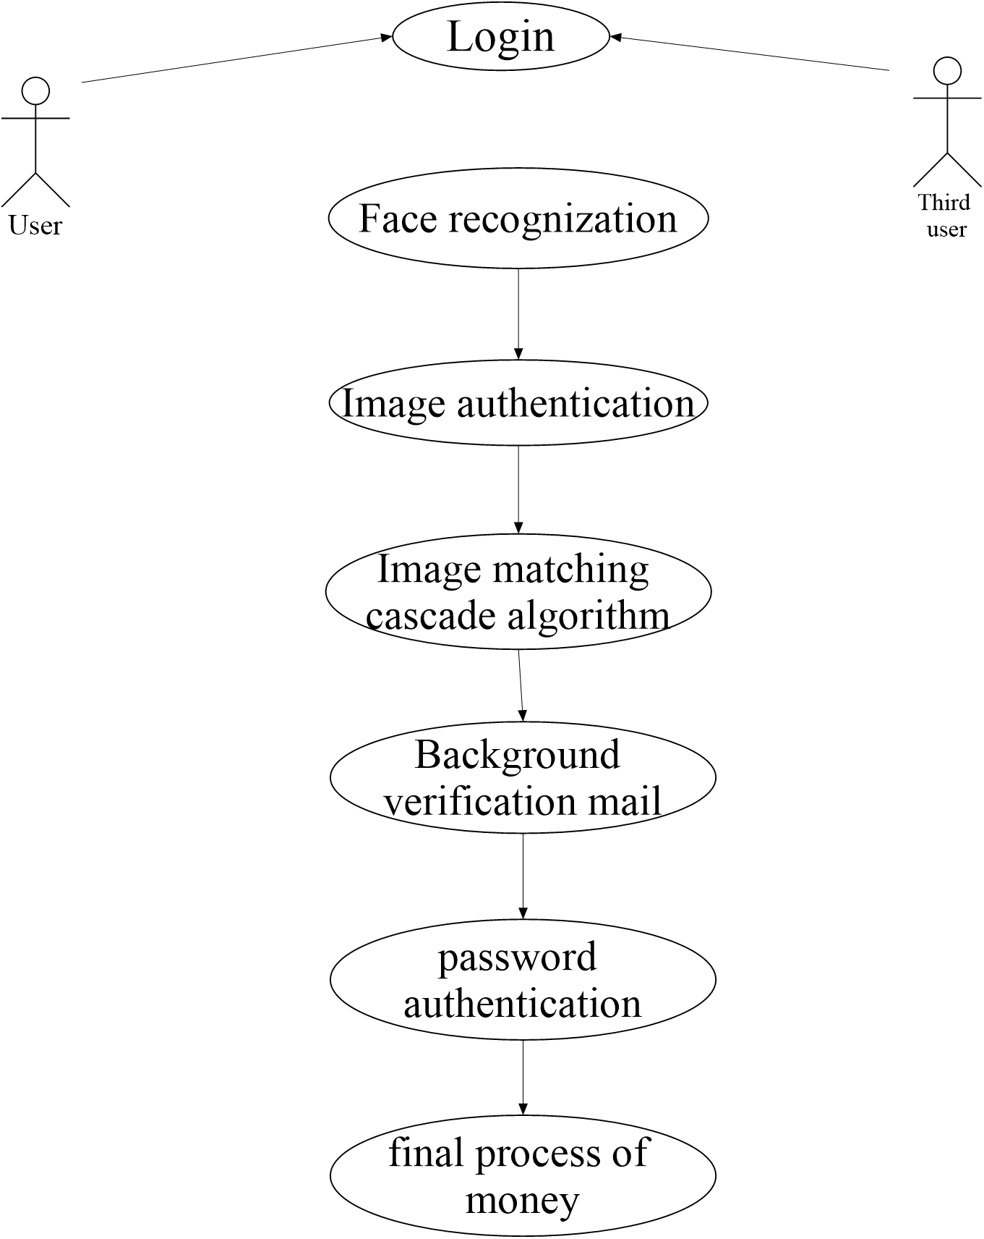

**CLASS DIAGRAM**



**ACTIVITY DIAGRAM**

